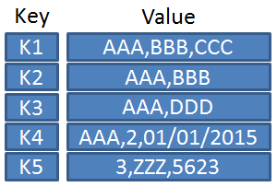
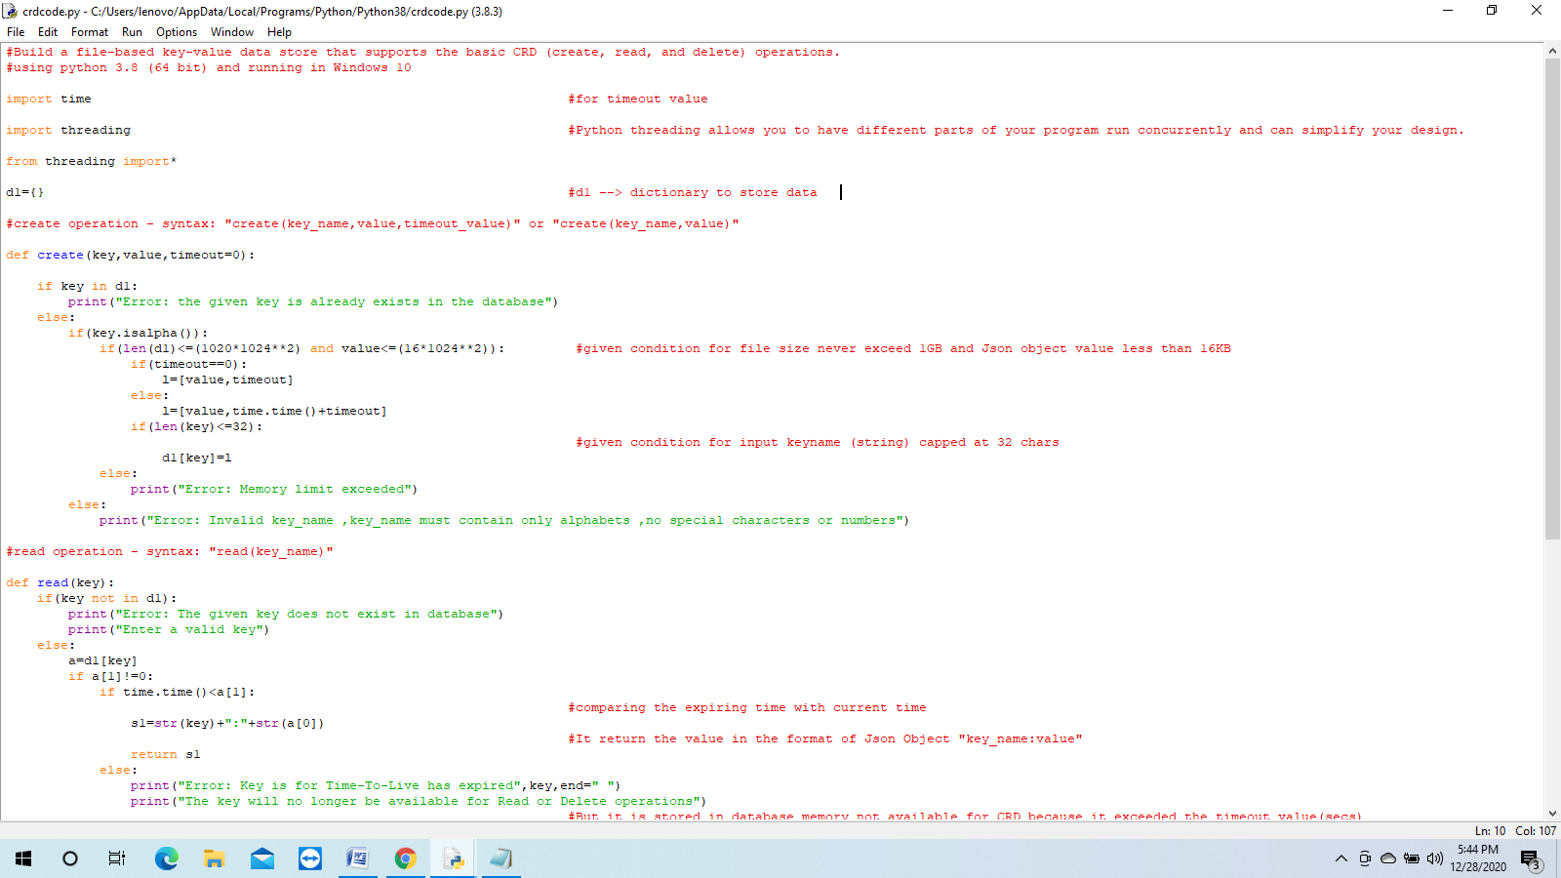
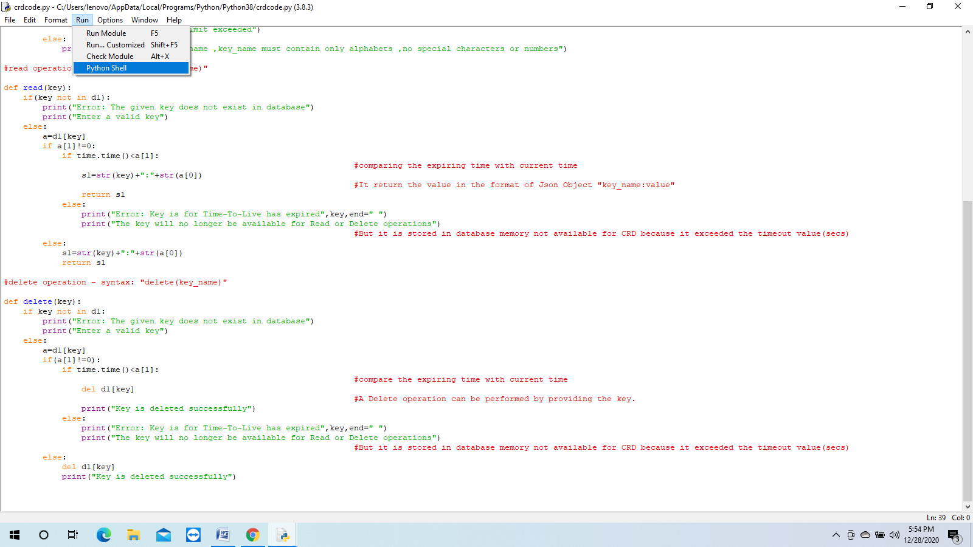
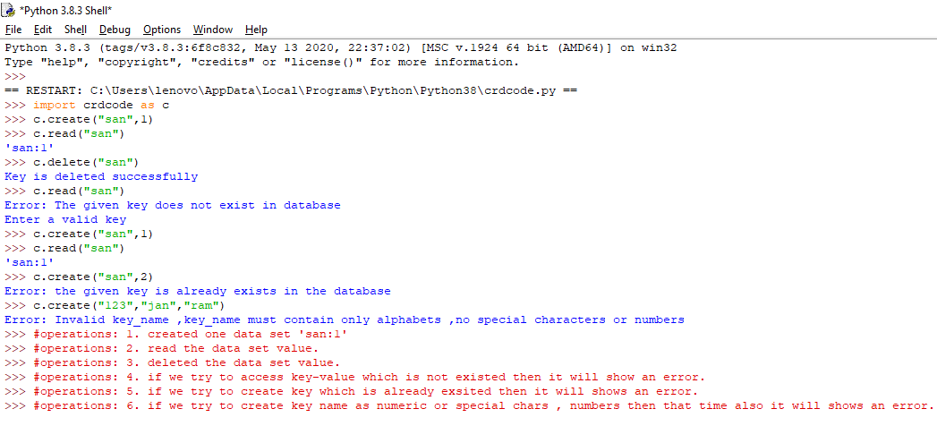
ASSIGNMENT-1
By FRESHWORKS

12/29/2020
Sandhya Rani Guntaka
MLWEC

PROBLEM STATEMENT :-
- Build a file based key-value data store that supports the basic CRD (Create, Read, Delete) operations.
REQUIREMENTS NEEDED :-
- WE NEED TO KNOW ABOUT 3 CONCEPTS TO CREATE KEY-VALUE DATA STORE :-
1 .Key-value data store:-
A key–value database, or key–value store, is a data storage paradigm designed for storing, retrieving, and managing associative arrays, and a data structure more commonly known today as a dictionary or hash table. Dictionaries contain a collection of objects, or records, which in turn have many different fields within them, each containing data. These records are stored and retrieved using a key that uniquely identifies the record, and is used to find the data within the database.
Fig : A table showing different formatted data values associated with different keys
2.JSON Object :-

Object Syntax

Example
{"name":"Sandhya","age":21,"car":null}
- JSON objects are surrounded by curly braces {}.
- JSON objects are written in key/value pairs.
- Keys must be strings, and values must be a valid JSON data type.
- Keys and values are separated by a colon .
- Each key/value pair is separated by a comma.
3.Thread-Safe:-
Thread safety is a computer programming concept applicable to multi-threaded code. Thread-safe code only manipulates shared data structures in a manner that ensures that all threads behave properly and fulfill their design specifications without unintended interaction. There are various strategies for making thread-safe data structures.
A program may execute code in several threads simultaneously in a shared address space where each of those threads has access to virtually all of the memory of every other thread. Thread safety is a property that allows code to run in multi-threaded environments by re-establishing some of the correspondences between the actual flow of control and the text of the program, by means of synchronization.

Code for to perform CRD operations:-
- Open python IDLE
- Click on new
- Write the code
- Save the code with filename.py

HOW TO RUN THE CODE:-
- After saving the code go to RUN icon and click on Python Shell.
Note: check your path properly i.e where the code is located. if not it shows an error at run time.
- Then import filename as var_name
Eg: import crdcode as c
- Perform CRD Operations.
Eg:
c.create(“San”,10)
c.read(“San”)
c.delete(“San”)

- Threading:-
We can also access these by using multiple threads :-
Eg:
T1=threading.Thread(target=(create or read or delete),args=”San”,1))
T1.start()
print(“thread_1 executed”) # thread_1 executed

